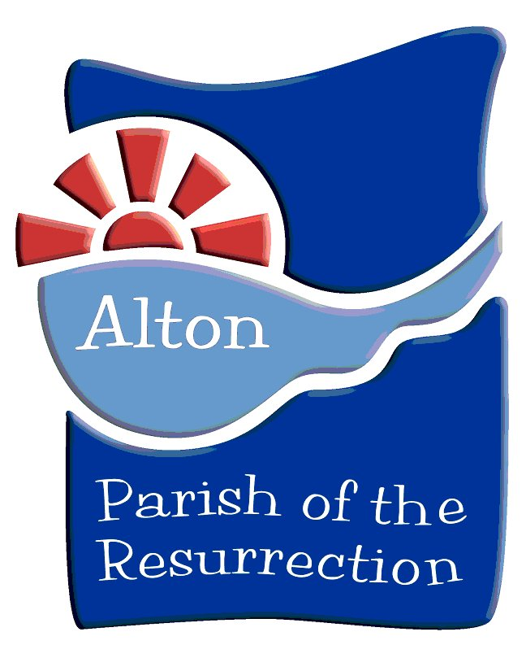

St Lawrence Church, Parish of the Resurrection, Alton

A Brief Guide to the Church

Plan at the back of this leaflet

Please return to the table by the entrance
Contents
Page
Doors 3
Royal Arms 4
Norman Church 5
Tower 6
Carvings under the Tower 7
Fonts 8
Lady or Galiliee Chapel 9
Piscina 10
Statues of St Michael and St George 11
Poor Box 12
North Aisle 13
Sanctuary and Railings 14
Reredos, Windows and Memorial Art in the Sanctuary 15
Choir Stalls 16
Organ and Music 17
Pulpit 18
Lectern 19
Wall Paintings 20
Brasses 21
Plan 22
Doors
The main doors still show signs of the Civil War battle in 1643, when a party of Royalist infantry were surprised by a larger force of Parliamentarians and eventually took refuge in the church. Their commander, Colonel Boles, was killed, reputedly in the pulpit. He is commemorated by a brass plate on the second column from the west end.

Bullet holes and a rectangular opening cut for a gun to fire through can still be seen in the old wood of the doors. Later, when the King heard of Boles’ death, he is recorded as saying, “Bring me my mourning scarf, I have lost one of the best commanders in this Kingdom.”
Royal Arms
The Royal Arms have been displayed in churches since Henry Vlll declared himself head of the Church of England. One of the oldest examples nearby is Elizabeth l’s in St Michael’s, Basingstoke.

Here, the Arms are in the church porch above the main door. Their heraldry dates them to the period 1801-1816, near the end of King George lll’s reign. They show the arms of England (top left), Scotland, Ireland (bottom left) and Hanover (itself containing Brunswick, Luneburg and Westphalia). The lion and unicorn supporters are lounging on the ground under the shield – in an early C18th style - instead of standing up and supporting the shield as they should.
The Norman Church

The 900-year-old ‘Norman’ style church was built to a cross-shaped plan. It was centred on the tower, which survives. A narrow nave extended westwards about as far as now and some of the carvings of the arcade can be seen in the south wall. The church extended to the east about half way to the present east window. Beside the south entrance door, there is a recess in the wall - a stoup for storing holy water with which members of the congregation would bless themselves as they entered. This was probably moved here from the old west door when the south door was made. There is also a ‘Romanesque’ font from about that time, now repositioned in the Lady or Galilee Chapel. The present ‘Early English’ Lady Chapel was built a hundred years later and the large main nave in the ‘Perpendicular’ style 600 years ago
Towers were built as a symbol reaching up to God in Heaven, especially if they had a spire like this one. They also served as look-out posts 500 – 1000 years ago when life was less secure. Bells were often hung in the towers to announce holy services and to alert the population in time of danger, as they did shortly after Dunkirk when invasion threatened in 1940. Clocks were also put near the top and told the population the time, often chiming the hours on the bells.

Alton’s tower dates from 1070 and the carvings on the arches inside are amongst the earliest figurative carvings in Hampshire. The bells date back 400 years but were recast in 1785, making a peal of eight (hence the name of the nearby pub!); the heaviest or tenor weighs nearly 1 tonne and its diameter is nearly 1.2m. Clocks have been set in the tower for 400 years. Previously there was a scratch (sun) dial, which can now be seen outside on an eastern buttress.
Carvings on the capitals of the pillars under the Tower

Like the murals and the stained glass windows, sculptures served to tell the bible stories to the illiterate mediaeval congregation as well as to decorate the church.

The most interesting at St Lawrence are those under the tower and they date from about 1070. They clearly depict animals and are often symbolic: a cock with feet upwards (St Peter’s denial), a pious pelican (its blood for the blood of Christ), a dove (peace), two playful donkeys on their backs (on which Mary rode to Bethlehem or fled to Egypt, or Jesus entered Jerusalem), a wolf eating a bone, and two or three green men (faces with leaves coming out of their mouths, ancient fertility symbols).
Fonts

Fonts hold the holy water used for Christening new members of the Church. The probable original font is now at the east end of the south aisle, to the south of the Altar, in the Lady or Galiliee Chael. The newer, Victorian, one is under the tower.

The old ‘Romanesque’ font probably dates from when the present building was erected; it was formed from one piece of stone and the old axe marks may be seen inside it. Thrown out in 1868, it went to Will Hall Farm and, later, was recovered in 1934. The new one was carved by the Rev OA Hodgson, Vicar of St Lawrence in 1867; its decoration shows the instruments with which Jesus was tortured and killed.
Lady or Galilee Chapel
When a church had more than one altar, it was common for the second to be dedicated to Our Lady, the Blessed Virgin Mary, Mother of Jesus, who was specially venerated by the Roman Catholic church, which built St Lawrence’s. So, when the new main nave was built to the north, this old altar was rededicated to St Mary. Now this chapel is set aside for prayer and peaceful contemplation and named after the picture of Christ the Healer by the Sea of Galilee in the east window.

This chapel was built early in the 13th century as a new enlarged east end to the old Norman church. The original width can be seen beside the east widow and high on the tower wall, where there are carvings of a Bishop’s crosier and mitre, a reminder of the Bishop’s authority after his Visitation in 1330 over disturbances at the Fair held in the churchyard, when the trouble-makers were excommunicated.

Piscina
The alcove/shelf to the right of the altar is the piscina for washing the communion vessels used in the Eucharistic service. This example can be dated to c1220 because of its double sink pattern. It has a drainage hole through to the outside of the wall.

This therefore dates the extension of the Lady Chapel. The original east end of the ‘Norman’ church, centred on the tower, came about halfway up the present Lady Chapel and was also narrower. The new building must have been completed early in the 13th century.
Statues of St Michael and St George

Statues, like the stained glass windows and murals elsewhere in the church, served to remind the illiterate mediaeval congregation of important Christian figures as well as to focus attention on the sanctuary around the holy altar. Originally the wider south niche, now St Michael, would have held the Blessed Virgin Mary with the baby Jesus.

These statues were presented in 1927 to complete the rededication of the old Lady Chapel to be the War Memorial Chapel of St Michael and St George. They were carved in wood by Mr Southwick, some of whose work is in Liverpool Cathedral.
Poor Box

Poor Boxes remind us of the Church’s historic role in providing social services. This continues in a large education effort in partnership with the local authority as demonstrated by our own St Lawrence’s Primary School beside the church, in soup kitchens in inner cities and in seminal reports on social issues in the country.

This box is over 400 years old and you can see the three locks, their keys held by the Vicar and two church wardens. There used to be a board above it, reading: “Remember the poore, and turne not thy face from any poore man and the face of the Lord shall not be turned away from thee. Tobit 4, 7 vers. If thou hast but little give little, if much give plenteously.”
North (Main) Aisle

This ‘Perpendicular’ building was probably completed about 600 years ago. Evidence for this can be seen on the corbel nearest the altar on the south side, which carries the head of a king, probably Henry lV. This building demonstrates the prosperity of Alton at that time and its need for more space.

It seems that the arcade of arches was built alongside the original ‘Norman’ church and the two aisles are now united in the one building. Some of the other old corbels have survived and you can spot some characters carved on them.
The Sanctuary, immediately around the altar, is the holiest part of the church and so is protected by these railings, which also provide support to members of the congregation when they kneel to take the Eucharist.

The Railings are said to have been the staircase balustrade and to have come from No 2, The Close, at Winchester. It was the home of Canon Thomas Ken. Legend tells that, unwilling to have King Charles ll’s mistress, Nell Gwynne, staying in his home during the King’s visit to Winchester, he had the roof taken off his house. Later, the staircase was brought here to the old Vicarage by former vicar, Canon Edward James, and sunsequently converted to these railings when his vicarage was demolished. Thomas Ken was later made Bishop of Bath & Wells by the King and wrote many hymns still sung today.
Reredos, Windows and Memorial Art in the Sanctuary
Like the carvings, stained glass windows and murals elsewhere in the church, these served to tell the bible stories to the illiterate mediaeval congregation as well as to decorate and focus attention on the sanctuary around the holy altar.

The reredos behind the altar was designed by Sir Arthur Blomfield in 1897 and shows Saints Lawrence, Swithun, Matthew, Mark, Luke and John either side of Our Lord’s Resurrection. The 1870 window above by Capronnier of Brussels showed the Ascension but only the main figures survived war damage. The 1899 window to the north shows the archangels Gabriel, Michael and Raphael and the 1906 mosaic frame shows Faith and Charity; they commemorate Mr and Mrs Hall, of the brewing family.
Choir Stalls
These seats are for the choir which leads the congregation in the singing of hymns during the services. The seats at the back were originally for the elderly, who found standing for long periods through the services difficult. Their seats were made to tip up to expose a smaller higher seat on which they could perch, while apparently standing.

These 15th century stalls came from Hyde Abbey in Winchester to which the two manors of Alton (Eastbrook and Westbrook) belonged after the Norman Conquest. The coats of arms on the candelabra (now lit by electricity) show the arms of the Dioceses of Canterbury and Winchester, to which St Lawrence owes allegiance, the gridiron badge of St Lawrence and the Greek letter abbreviation for Christ

Organ and Music

Psalms and hymns of devotional words (praise and penitence) have been used during services for hundreds of years. Before the organ, a band of musicians played in the west gallery. A choir would also have led the congregational singing from up there.

In 1830, a Bryceson barrel organ replaced the musicians; it had 6 stops or sound colours. When the gallery was demolished in the 1860s, a new Speechly organ with 33 stops was installed in the rebuilt north chantry. After improvement, notably by Wood, Wordsworth in 1966, it now has 3 manuals and nearly 60 stops. 150 years ago, the choir had 8 boy trebles, 3 boy altos, 4 tenors and 4 basses. The boys were paid by an annual present of a book worth 7s 6d, which was reduced by a 1d fine for each absence without leave.

Pulpit

From here sermons are delivered which discuss the relevance of Christianity to our daily lives, usually based on bible readings in the service. These sermons dominated worship in the 19th century, when the pulpit was halfway down the nave, opposite the main entrance and all the pews faced it.

This fine carved wood pulpit dates from the 17th century. It originally had a sounding board above it to project the preacher’s voice towards the congregation and it may have been part of a three-decker pulpit, with desks for the vicar and the parish clerk. Tradition relates that, at the climax of the battle of Alton in 1643, Colonel Boles, with sixty of his men around him in the church, was killed in the pulpit by the Parliamentarian troops.

Lectern

As can be seen, the lectern supports the bible from which readings are given during the service. It also serves as a rostrum for other announcements, in a less formal setting than the pulpit.

This lectern was carved by the curate, Rev AW Deey, in the 1860s during the major restoration then. His vicar at the same time carved the ‘new’ font under the tower. The lectern, as so often, is in the form of the eagle of St John, the Evangelist.

Wall Paintings

Like the carvings and the stained glass windows, wall paintings served to tell the bible stories to the illiterate mediaeval congregation, reminding them of the Saints and the example they set, and also to decorate the church. Most Churches were a riot of colour in mediaeval times.

These paintings must date from the early 15th century. They are believed to show: from the top, St Cornelius, a contemporary of St Lawrence and Bishop of Rome, who died in AD 253; a king, perhaps Henry lV, alive when the nave was built, or Edward the Confessor, whose Queen Edith held the Manor of Alton ; and at the bottom a martyred bishop thought to be Thomas à Becket, whose cult was popular at the time - Alton is on the Pilgrims’ Way between Winchester and Canterbury.

Brasses
Memorial brasses to individuals are often to be found on the walls or in the floor in churches.

The oldest in this church is framed by a monument on the south wall of the Lady Chapel; the inscription records Richard Clarke, died 16th April 1485. There are two small figurative ones, c 1510, at the foot of the first pillar from the west end but they are unidentified. Higher on the pillar is an inscription to Christopher Walaston, Keeper of the Royal Goshawks to Henry Vlll, Edward Vl, Queen Mary and Queen Elizabethe: he died16th January 1563. Col Boles is commemorated on the next column. Canon Edward James, a C19th vicar is commemorated on the easternmost pillar.

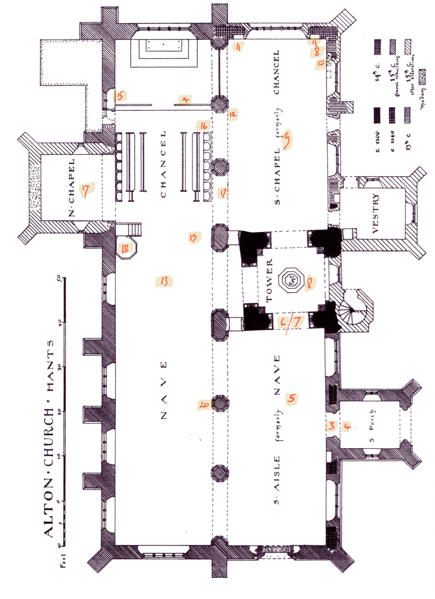
Plan of St Lawrence Church, Alton

