Attached photos HLF Programme
St Lawrence Church, Alton
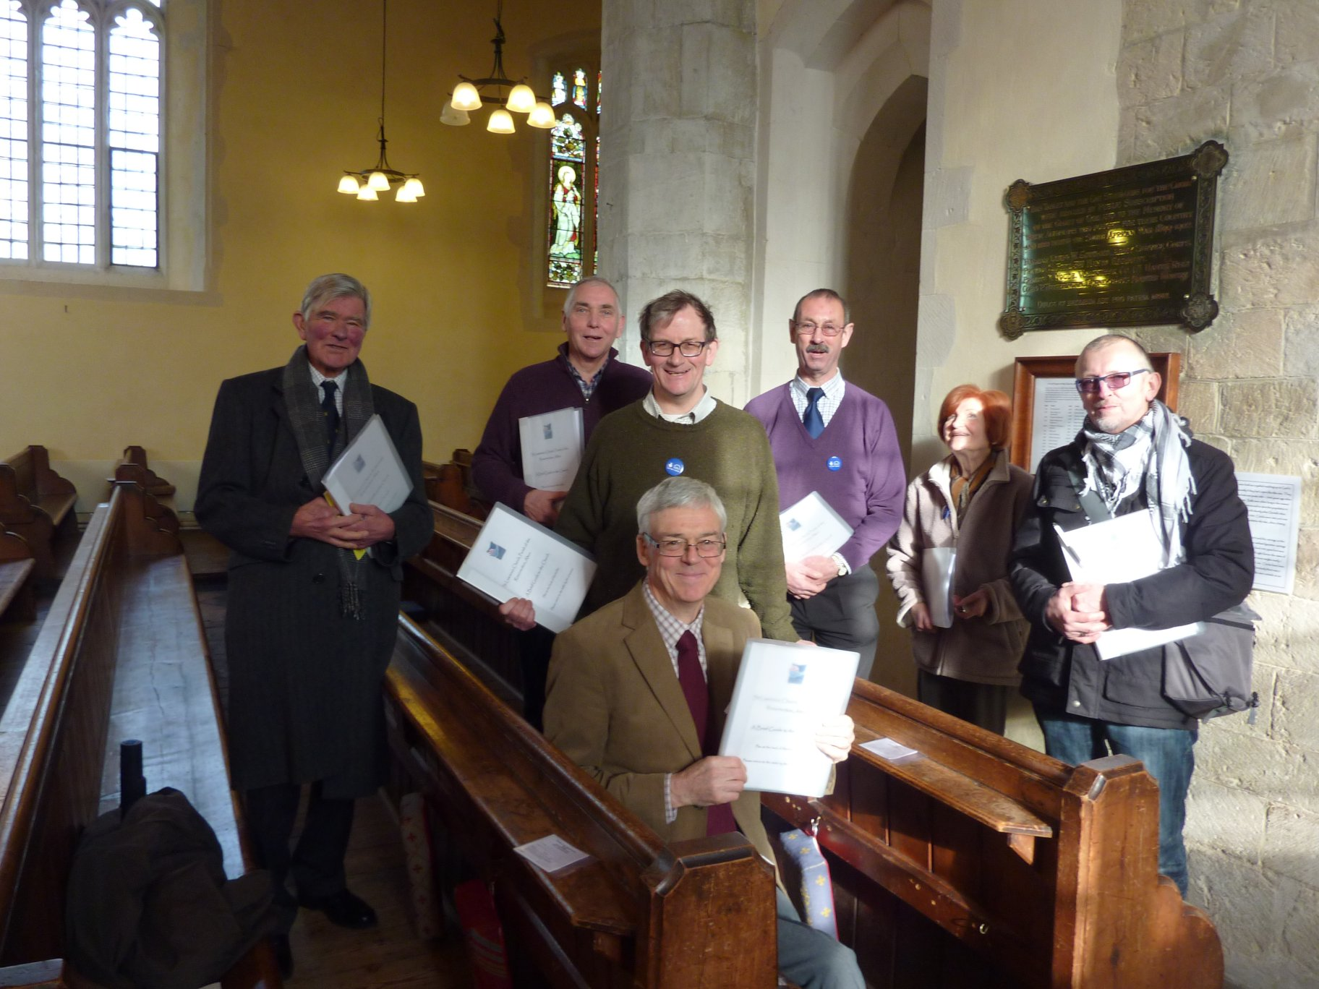
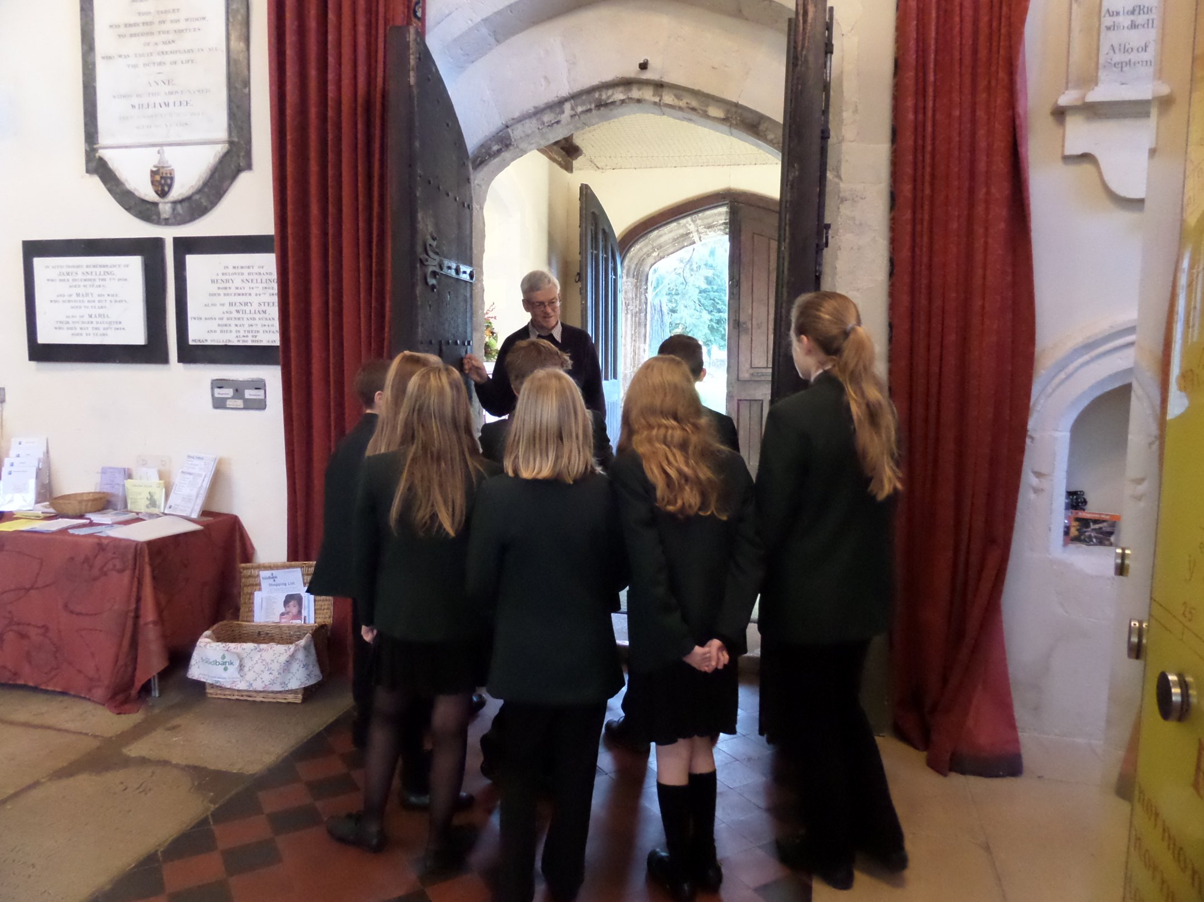

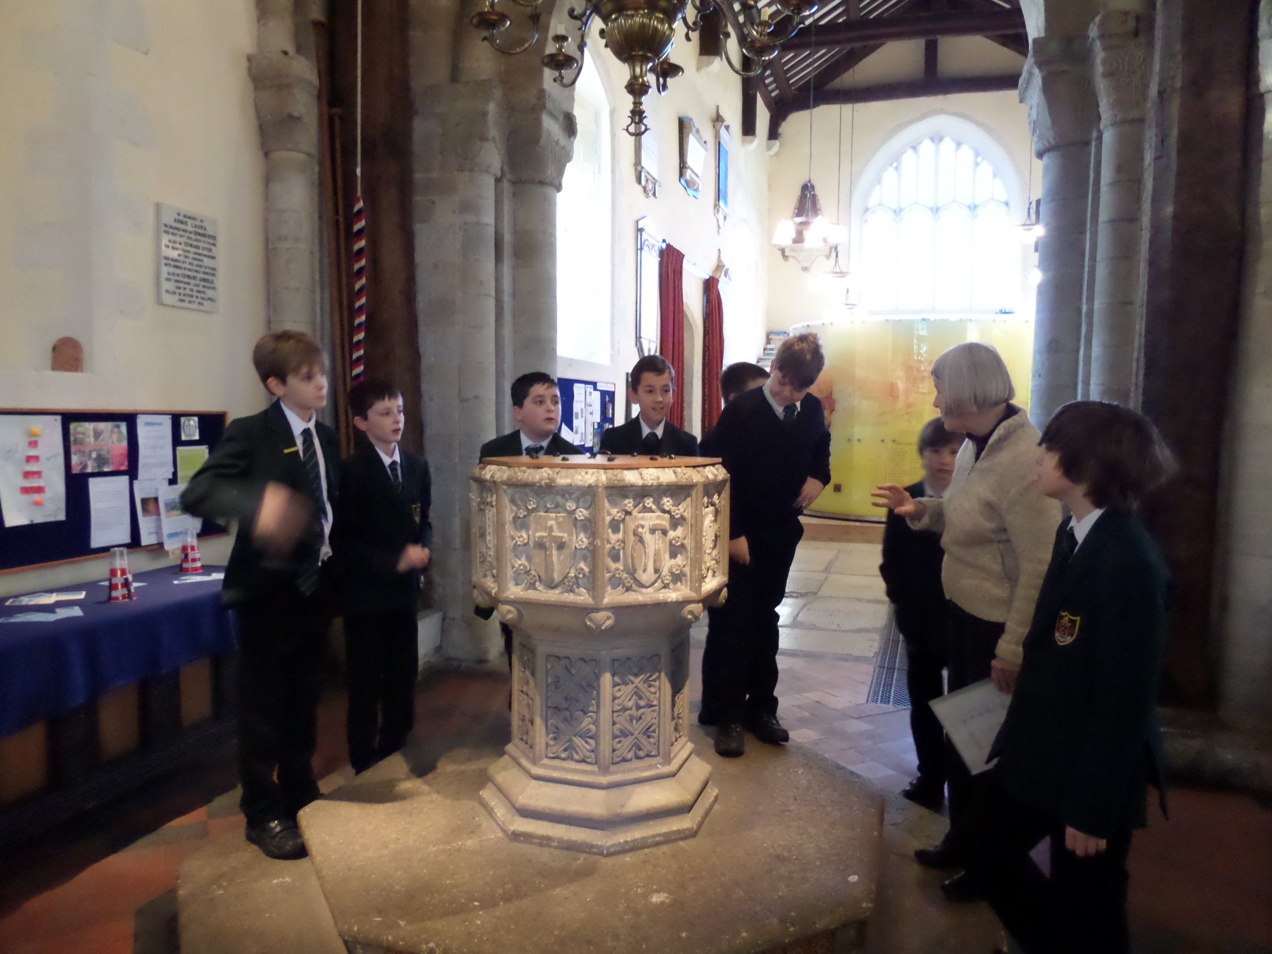
First training session for some of our Heritage Leaders, holding their briefing folders.
Visit by Year 7 pupils from Eggars School, right.
Tours of the church included the main door, damaged in the Civil War and the Victorian font.

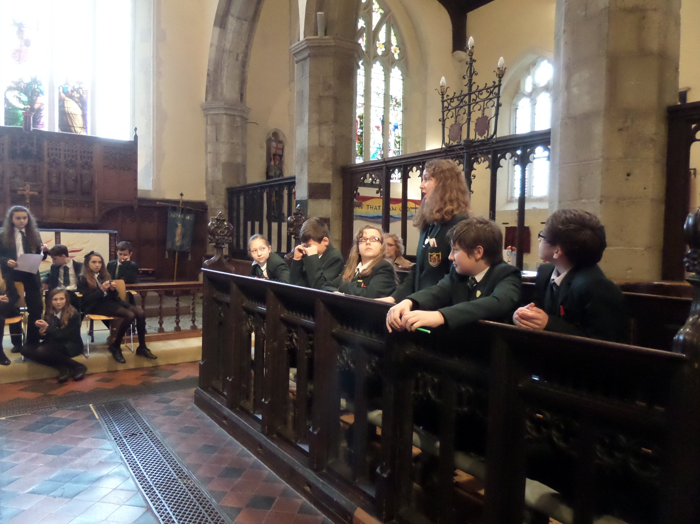

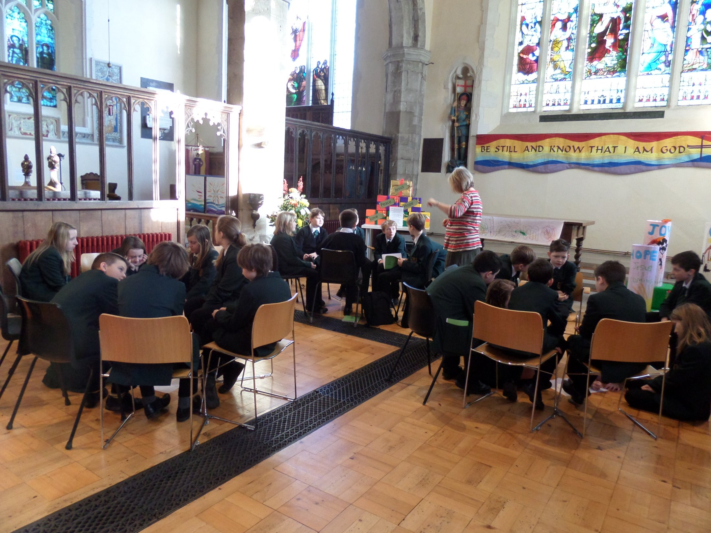
Year 7 Eggars visit. Vigorous discussion about who was to blame for Thomas à Beckett’s death, using the choir stalls as a debating chamber.
Year 7 Eggars visit. In the Galilee Chapel, preparing arguments for the debate.

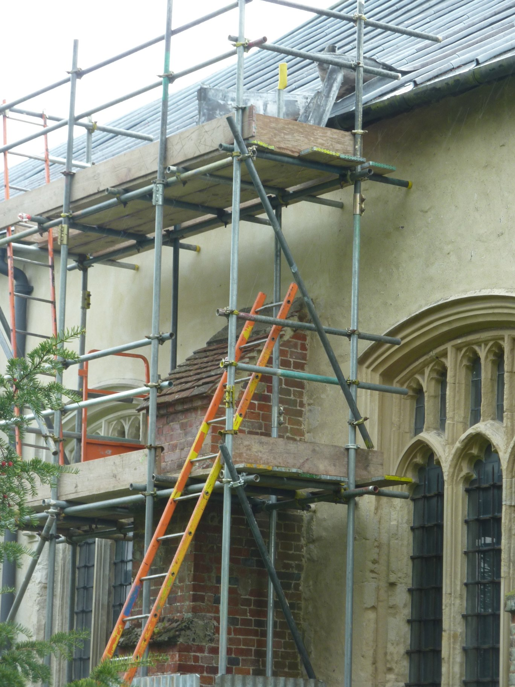
Members of the 8 a.m. congregation learn about the HLF programme

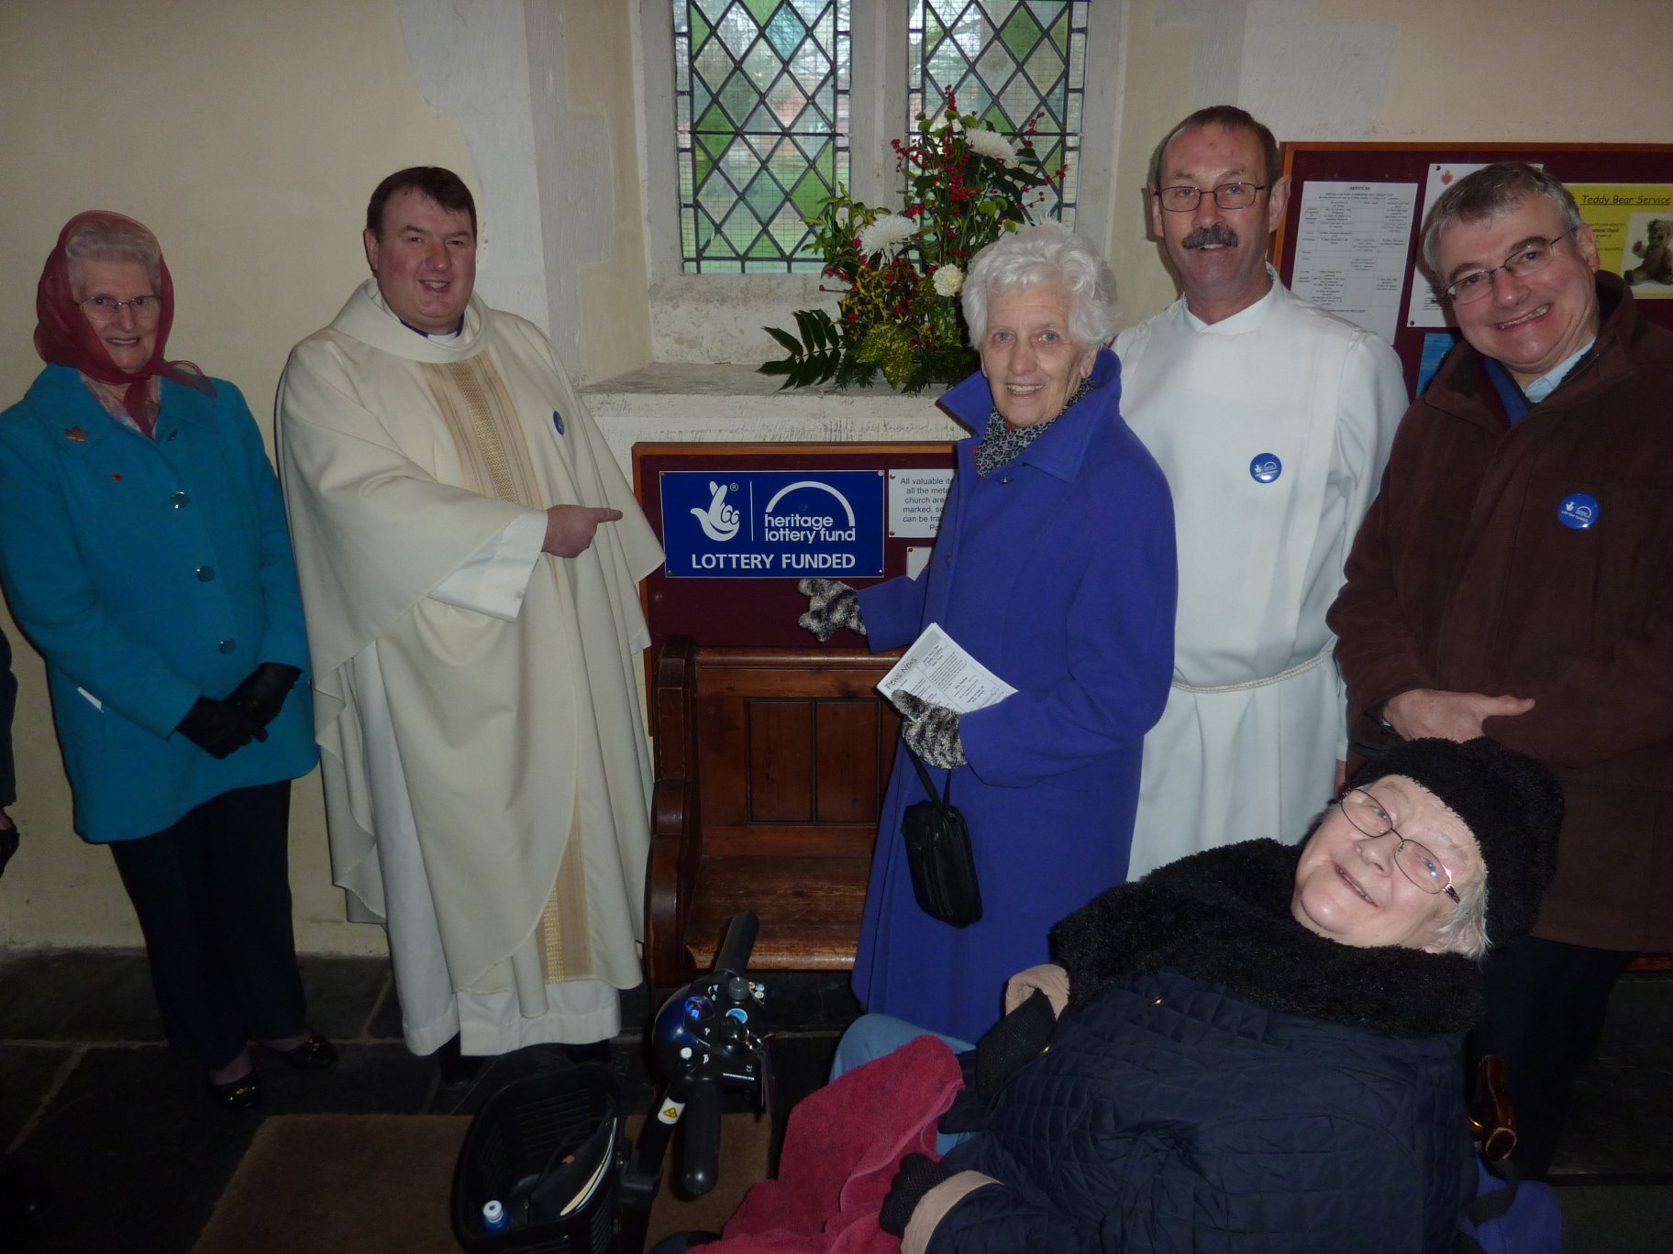
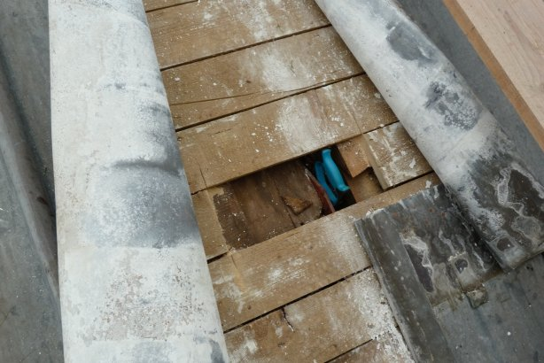
The scaffolding is up, to enable investigation of the roof beams, after bending back the lead layer
The lead is peeled back on the roof to expose corrosion, due to condensation.

