Alton Deanery’s Overseas Link serving the Church of Uganda in Karamoja
BURSARY SCHEME
for
St Andrew’s Diocesan Training Centre (DTC)
2014 - 2015

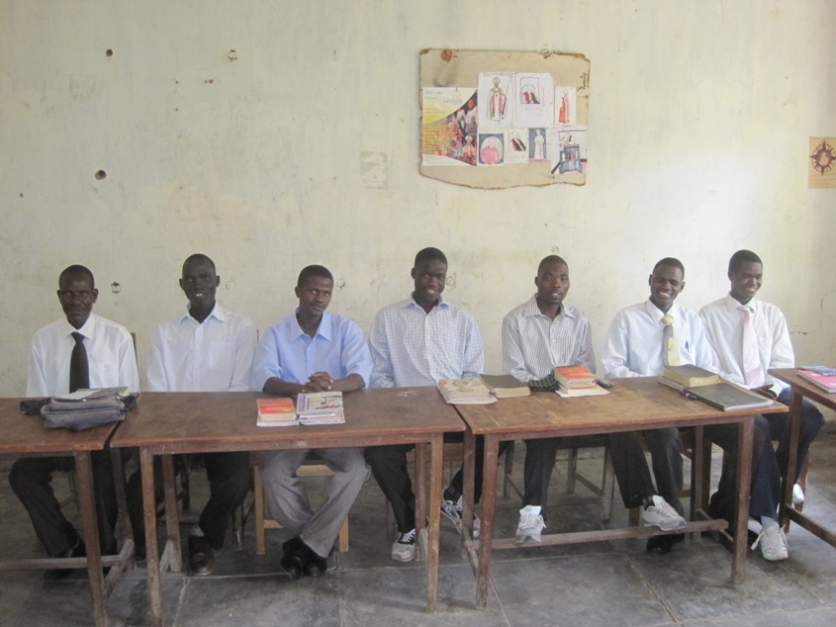


“Still other seed fell on good soil, where it produced a crop — a hundred, sixty or thirty times what was sown.” Matt 13:8
“Still other seed fell on good soil, where it produced a crop — a hundred, sixty or thirty times what was sown.” Matt 13:8
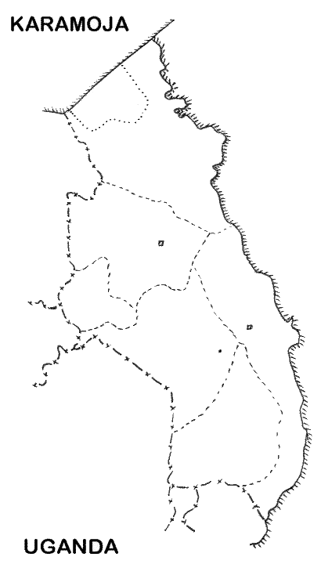

WHO?
Training of ordinary Christians - future leaders, some of whom will go on to study for the full-time Christian ministry at Uganda Christian University, Mukono, or other colleges.
The need to train more leaders is a priority.

WHERE?
The DTC is a small regional training centre jointly run by the two Karamoja dioceses. It has accommodation for 12 - 14 students and is situated at Lotome, 45 minutes from Moroto (the principal town of Karamoja).

WHEN?
Two year residential course; the first term will now start in February 2014 and the course will run until December 2015.

Kotido
Moroto
DTC (Lotome)
North Karamoja
Karamoja (South)
●
●
●
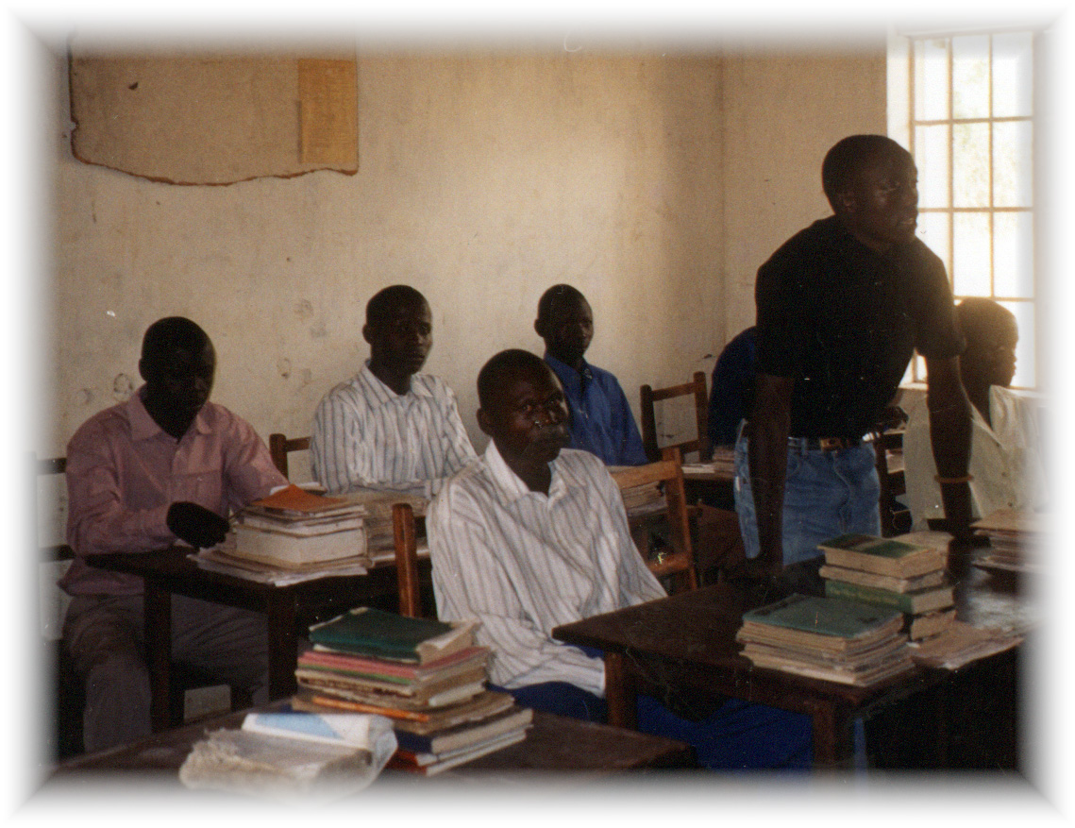


COST?
£750 per student per year for two years (£1,500 in total). This will cover all the student’s costs of tuition, transport and food; in the past, an inability to meet these costs has prevented many from starting training.

The DTC expect to admit 11 students and it is hoped to support all of these with bursaries. This number of bursaries should be sufficient to meet the full running costs of the DTC, including paying the Principal, several part time tutors and three other support staff.

Ideally, we look for pledges to cover the full two-year course (£1,500), payable over the period of the two years. Donations (regular or one-off), however, of less than this are also welcome. Sponsorship could be from an individual, a group of Christians or from a whole church.

FEEDBACK
Information about each student will be provided to their respective sponsors with a photograph and biographical details.

BURSARY SCHEME CONTACT
For more information please contact Elizabeth Dain (Treasurer)
57 York Mews, Alton, Hants GU34 1JD
Tel: 01420 89062 Email: dainbs@btinternet.com

BACKGROUND
The Bursary Scheme was started to enable the Training Centre to operate at full capacity for the duration of the two year course. Before this, many parishes were unable to provide sufficient funds to cover the fees and students were unable to find even the money for bus fares to attend. The course prepares lay workers to minister more effectively within their parishes, especially in areas where there are no clergy.

The scheme has been chosen as the main fund-raising project for our Deanery Link because the training given builds up the capacity of the lay workers who are directly enabling the mission of the churches. This fits well into our remit from the Diocese of Winchester.

Despite the tough conditions, the Principal and his support team are making a real difference. Of the 14 bursary students on the 2007-2009 course, nine graduated, four with 1st class honours, and one went on to theological college to study for ordination. 13 students started the 2009-2011 course of which Alton sponsored nine; 10 students graduated, all sponsored by Alton, including one who had missed a term during the previous course; one bursary student was awarded 1st class honours. All seven bursary students on the 2012/2013 course are expected to graduate shortly. A further three sponsored students started in 2013.

Most students return to their home parishes either to support their parish priest or to be in charge of their parish or sub-parish. One such student, now a leader and lay reader working with the Ik people in Timu, in a mountain parish a three-hour drive from Kotido, saw 111 people baptised in his first year and has overseen many more baptisms since. He has organised the church community to build its own, now very full church comprising a timber and corrugated-steel roof on steel pipe supports with bundles of grass for walls to provide further protection from the elements, particularly wind and dust.

