**Parish of the Resurrection Alton**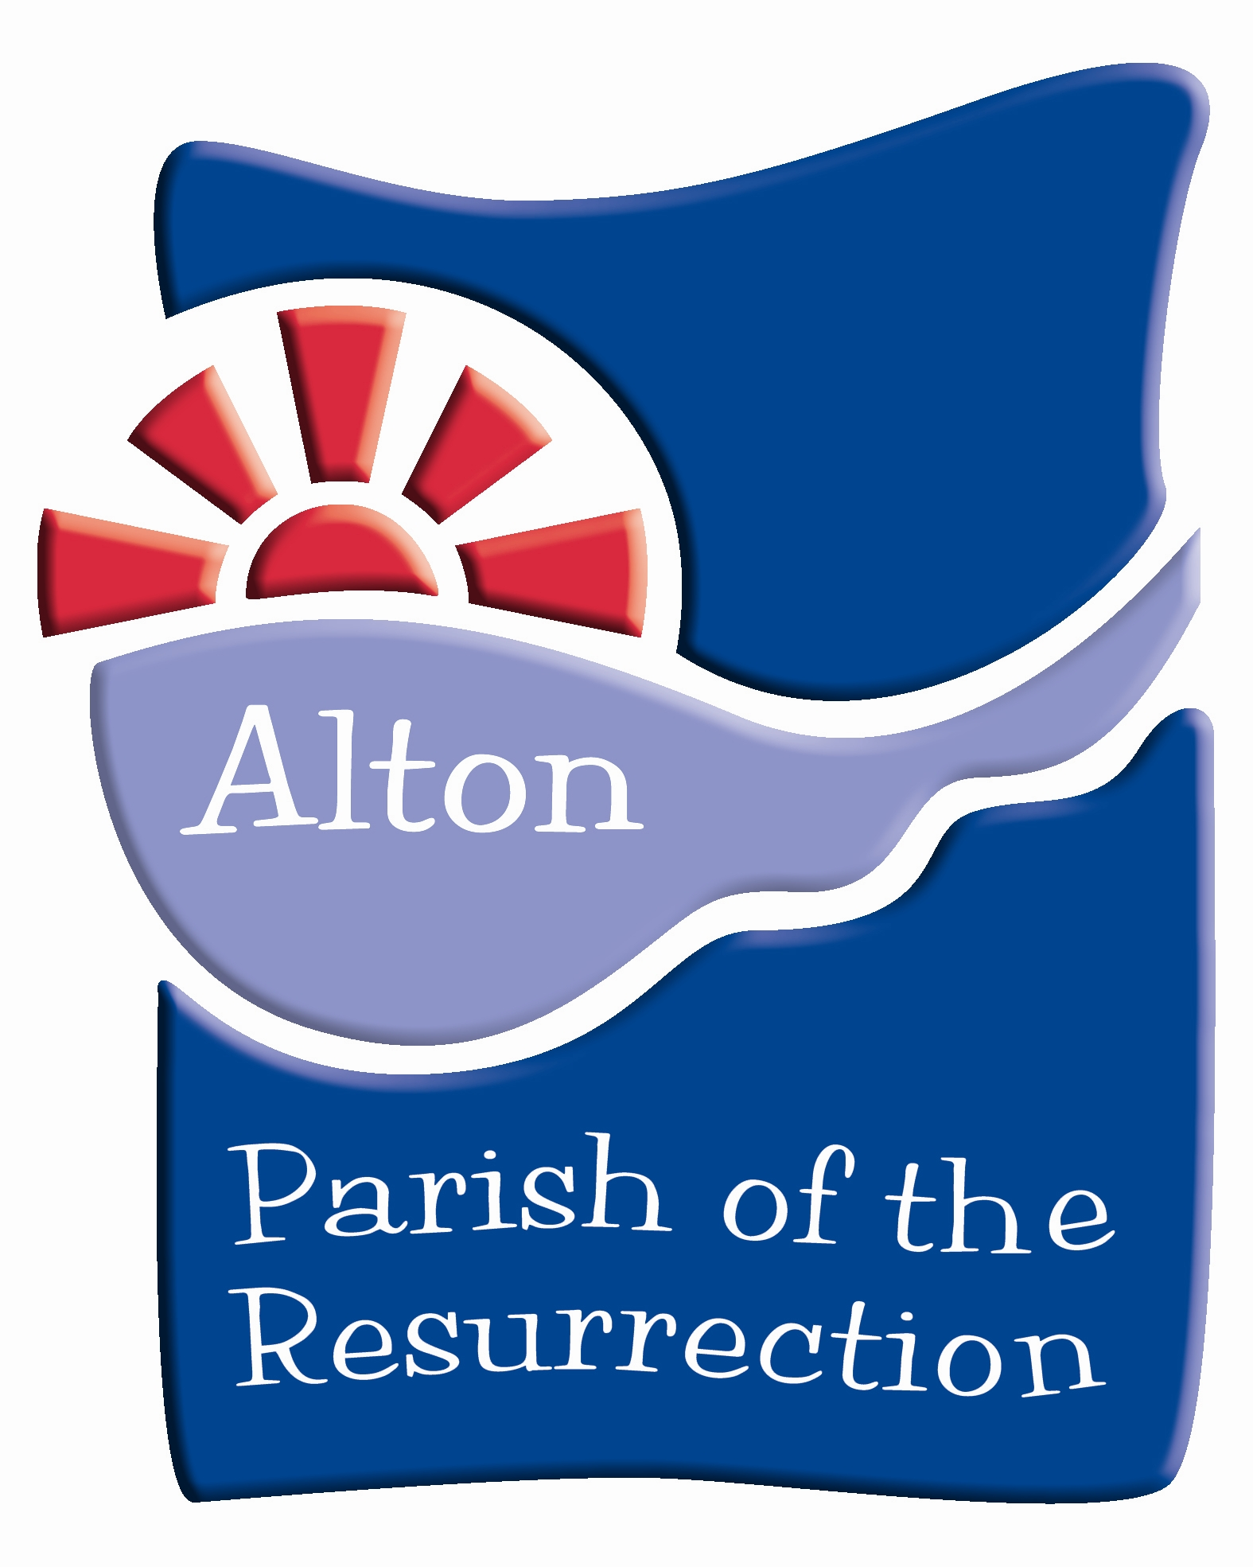

**Baptism & Christening Policy**

**Child Baptism**

Any parent residing in the parish can request baptism or ‘christening’ for their child in All Saints Church, The Church of the Holy Rood, St Peter’s Church or St Lawrence Church. This policy is written to set in place the procedures to which The Ministry Team, The Parish Office and any future volunteers adhere.

Baptisms will normally take place:

* + - * All Saints Church at a 12.30pm set aside baptism service on the 2nd Sunday of any month
      * Church of the Holy Rood, Holybourne at a 11.30pm, and sometimes at 12.30pm too, set aside baptism service on the 3rd Sunday of any month
      * St Lawrence Church at a 12.30pm, and sometimes at 1.30pm too, set aside baptism service on the 4th Sunday of any month
      * St Peter’s Church at any service which is convenient or at another time in consultation with the Parish Office and the Clergy

If parents live outside the parish, the baptism can go ahead if they fulfil one of the following criteria:

a) They were married at one of the churches in the parish - the baptism will take place in the same church

b) They worship regularly (once a month) at the church where the baptism will take place for at least six months before the baptism

c) Their own parents (i.e., the grandparents of the child to be baptised) are regular worshippers in the parish

If the family lives outside the parish, but has some other connection with the parish they may be eligible, but this must be referred to the Vicar (or in his/her absence the Associate Vicar) for a decision.

A family asking for baptism who live outside the parish and have qualified under the criteria set down above must inform the Vicar of their own parish, and should only proceed with his or her goodwill in accordance with Canon B22.5

If the family has been attending one of the churches of the parish for fewer than six months and live outside of the parish but have shown themselves to be sincere and committed members of the congregation they will be encouraged to add their names to the Electoral Roll and baptism goes ahead.

Baptism preparation involves attendance at the Baptism Preparation session which is held at The Parish Centre on the 2nd Sunday of the month at 3pm. This explains the service content, the alternatives to baptism which exist within the Church of England, the commitment baptism entails, puts the family in touch with members of the Parish Baptism Team and the children’s ministries of the parish and books the date and place of baptism. The Baptism cannot take place without attendance. In addition all families are invited and strongly encouraged to attend a Church@4 or other relevant service to be welcomed or depending on age or circumstance at another relevant church service.

**Godparents**

Godparents must themselves be baptised. (Canon B23.4)

A Godparent can be baptised at the same service at which they act as a Godparent for the candidate for baptism.

The name of a Godparent can still be entered on the Baptism register if for good reason they cannot attend the service.

A Godparent can, if desired, be represented by a ‘proxy’ at the service if they are unable to attend.

If an unbaptised person in not willing to be baptised before or at the service at which they wish to be a Godparent, they cannot be a Godparent or be entered into the register as such. They can be a ‘sponsor’ but they are not entered into the register and they cannot be part of the service in the same way as a Godparent.

We recommend that there a maximum of five Godparents for each child.

**Adult Baptism**

Adult candidates for baptism will receive preparation from a member of the parish clergy and arranged separately.

All adult candidates for baptism will be reminded of the requirement to consider Confirmation as well as baptism (Canon B24) and if this is required should form part of the annual parish Confirmation Service with the Bishop.

**Booking Procedure**

All bookings are taken by the Parish Office - any requests outside of the Parish Office must be passed on after a conversation of welcome and congratulation.

The Parish Administrator/Baptism Booking Co-ordinator talks through the requirements outlined in this policy with the contact person. A follow on letter is then sent either in the post or by email which explains the policy and procedures and encloses an invitation to the Baptism Preparation Session.

The booking form for the required information is completed at the Preparation Session and the date for the Baptism is discussed and confirmed at the same time. At the same time there is an encouragement for all families to attend a Church@4 service. Also depending on age or circumstance candidates will be welcomed at another relevant church service. It is about making and growing a relationship between families and candidates and the church community.

July 2024