

 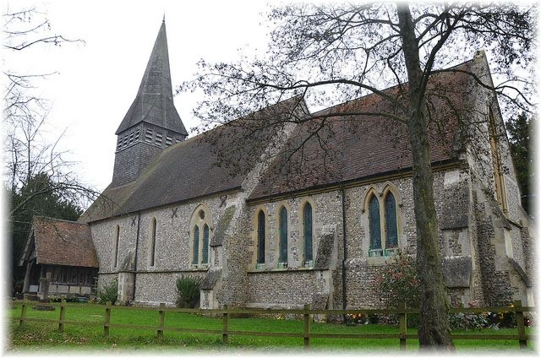

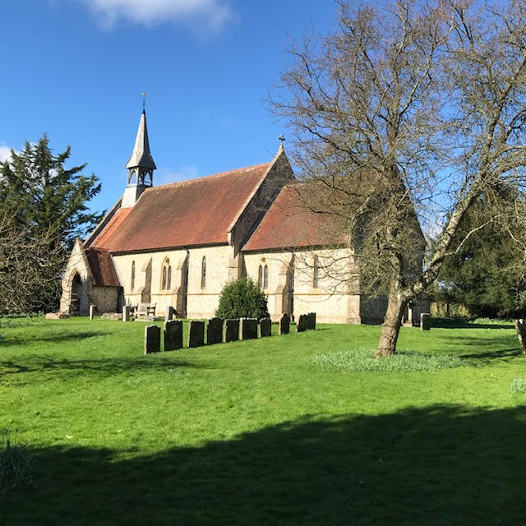



**Aims and Purposes:**

The Parish of BLS PCC has the responsibility of cooperating with the incumbent Revd Andrew Micklefield in promoting in the ecclesiastical parish the whole mission of the church, pastoral, evangelistic, social and ecumenical. The PCC is also specifically responsible for the maintenance of the three churches and churchyards.

**Administrative Information:**

The Parish of BLS comprises the churches of St Mary’s Bentworth, St Mary’s Lasham and St Peter and St Paul Shalden.The Parish is in the Alton Deanery and part of the Diocese of Winchester within the Church of England. The correspondence address is Catherine Dumelow, Woodlands, Medstead Road, Beech, Hampshire GU34 4AJ. The PCC is a charity exempted from registration with the Charity Commission.

PCC Members 2024

Incumbent and Chair Revd. Andrew Micklefield Vice Chair Peter Rankin

Church wardens: Catherine Dumelow (Bentworth); Sarah Miskella (Lasham); Peter Rankin (Shalden) Treasurer Mervyn Dunwoody Secretary Catherine Dumelow

Deanery Synod Representatives Mervyn Dunwoody (Bentworth); Antonia Goor (Lasham); Michael Campbell (Shalden)

Congregational Representatives Liz Preece (Bentworth); Kirsty Ennever (Shalden)

**Safeguarding Officer:** Cathy Boyes

**Church addresses:**

St Mary’s Church, Bentworth, Hampshire GU34 5RE St Mary’s Church, Lasham, Hampshire GU34 5SD St Peter and St Paul’s Church, Shalden, Hampshire GU34 4DU

**Activities of the PCC:** The PCC of BLS was formed at a Special Annual Parochial Church meeting on 15 April. The PCC subsequently met four times in 2024 with a 100% attendance.

**Vicar’s Report**

This is my first and last Vicar’s Report for The Parish of Bentworth, Lasham and Shalden. By the time you read this I will have been installed into Winchester Cathedral as Canon Treasurer. This gives me another opportunity to express my deep gratitude for all you have been over the years I have known you. I really meant what I said in my final sermon - ‘Andrew, what are we going to do without you? The only appropriate reply and response to a community of people who are humble, healthy and hopeful is: What am I going to do without you?’ You have been a fantastic support, encouragement and my friends. And I am sure you will be to the next incumbent.

2024 has been a year of change. Change is not always a bad thing. Indeed, without change we cannot live. I think Sir Isaac Newton had something to say like that! In April we officially became a two-parish benefice with the pastoral scheme creating Bentworth, Lasham and Shalden as a united parish and then joining them alongside POTR. This was not a surprise as we had been working very successfully together for well over two years as the legal processes were all drawn together. It is good to see POTR people worshipping in BLS churches and vice versa BLS people in POTR services. It all seems so seamless! We pray for further unity and a greater friendship between us all.

We welcomed the Chattell’s into our midst as David joined as Associate Vicar and what a pleasure that has been. Ruth has also been exercising her many gifts, her licence as a Licensed Lay Minister was transferred in the same service David was welcomed. They have quickly become an integral part of the Parish and particularly the community of Holybourne. We are reassured by David’s calm and collected approach and years of experience.

At the end of the year Kate Powell, our wonderful Anna Chaplain, gave her notice and the news that she will be joining the Southampton Port Team as a chaplain there. We will miss her very much and we are greatly blessed by all that she leaves in place and flourishing in the world of our ministry with older people. Who knew that we could have so many Anna Friends and doing so much excellent ministry. We will hope to make an appointment to this important role soon.

In the diocese we welcomed Philip Mounstephen as our Diocesan Bishop in February. There was a wonderful service in the Cathedral and we are in very safe hands. We look forward to his ‘Walking the Wessex Way’ vision taking root and all that he offers. We are also acutely aware that Bishop David was announced as the next Bishop of Truro in December and we are very sad to lose him. His support and presence in our parish has been exceptional and we will miss his friendship. Truro’s gain is very much our loss. Who will forget the fabulous opening service of the newly re-ordered Bentworth Church.

Amongst all this we combined the two deaneries of Alton and Alresford. I have been the Area Dean of both and we have benefitted hugely from the combined Chapter meetings and Synods. I express my thanks here to David Chattell who has been Assistant Area Dean, to Derek Gurney and Gillian Gray-Knight who have been Lay Chairs and to Elspeth Mackeggie Gurney as Finance Chair.

No parish can operate effectively without good church wardens and PCC members. So much of what they do goes on under the radar without being noticed but is essential.  The PCC team work collegially and systematically tackling many things which are complex and time consuming.  Their work is so important, thank you so much for all that you contribute and the ways in which gifts are exercised.  Underpinning all this and much more is the tireless work of Philippa Penfold and Ellie Elder our Benefice Administrators. We heavily rely on their gifts and skills and are aware that they work well beyond their contracted hours to make sure all is completed. We have increased the hours of work for them and I am sure we have all rejoiced in their ministry to us.

I am so pleased to be a part of such a prayerful, dynamic and mission-focussed Christian

community.  So many people come together to reach out in and outside of our churches.  I am also so thankful that very little relies on me and that activities, events, services and more just seem to gracefully take place. We remain strong to our values and vision.

We rely not on our own righteousness but on God’s great and manifold mercies. We humbly come before Him and we give thanks for all that has been achieved through his grace and giftings. All praise to him for all that has been in 2024 in this our wonderful Parish and we yield to him for all that is to come.

With my very best wishes

Andrew

**Church Services:**

The three churches settled to a pattern of 2 services per month supported by the generous clergy of POTR. These were mainly Communion services but Shalden scheduled monthly Evensongs with all churches having extra services to commemorate Easter, Harvest, Remembrance and Christmas. There were 4 funerals and 2 baptisms and 1 wedding.

**Church Fabric and Churchyard:**

**Bentworth**. 2024 saw the culmination of a programme to improve the facilities at St Mary’s with the addition of an accessible toilet, storage space and kitchen. The heating, lighting and sound systems were all upgraded with all works carried out under the direction of the DAC and Mr Nick Carey-Thomas RIBA. The original boiler was deemed to be fit for purpose and a pressurised system was added to facilitate the introduction of underfloor heating at the back of the church. The fire alarm system and signage were also upgraded to meet current safety standards. The pews at the back of the church, many of which were cramped, were removed and replaced with 40 upholstered chairs. This has allowed the church to be used more extensively for talks, meeting and small family parties.

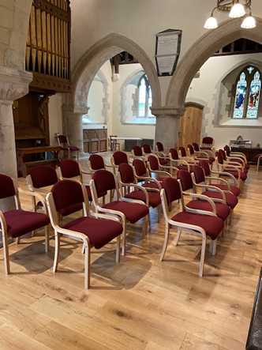 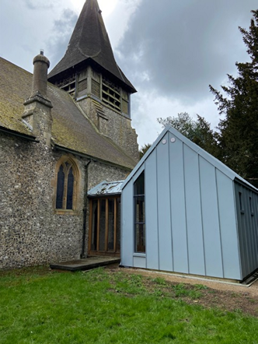

The churchyard continued to be maintained by volunteers on a mowing rota with an annual ‘Churchyard’ tidy session. Many of the areas had become overgrown and inaccessible so it was deemed necessary to employ contractors to deal with this dense growth. A new lychgate was provided free of charge by a local craftsman. The church yard continues to be a place of sanctuary and peace for walkers and during the building work every effort was made to ensure accessibility for all.

**Lasham:** A faculty was obtained to proceed with the repair and renewal of the rainwater services on the southern roof of the church replacing the existing plastic guttering with extruded aluminium guttering. The mechanism for ringing the bell was renewed. The flower beds in the churchyard continue to give pleasure and also provide a colourful supply of flowers for the church.  The flower bed boxes themselves have been replaced after they were showing distinct wear and were falling apart.

The plans for the inside re-ordering of St Mary's to provide an accessible toilet, kitchenette and to open up the church to facilitate a community hub space (incorporating rectifying the lifting and damaged floor at the west end) has progressed well.  The faculty has been submitted and we are awaiting a decision from the Diocesan Advisory Committee.

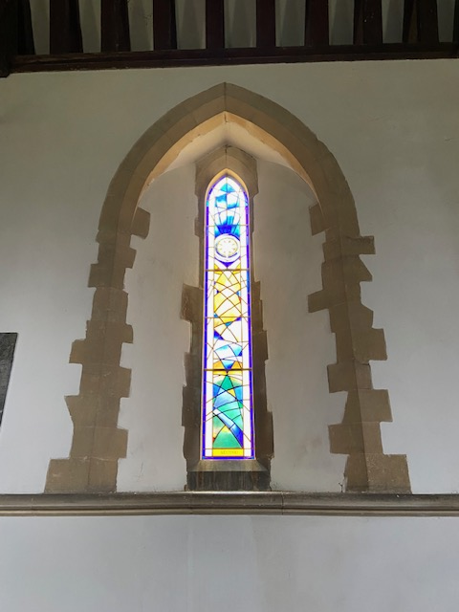 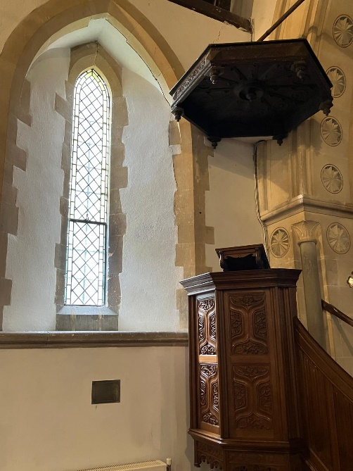

**Shalden:** The final external works to ensure that the church building was weatherproof and in good order to comply with our last Quinquennial Inspection in 2019 was completed in 2023. Our original Walker pipe organ from 1873 following extensive refurbishment in 2023 was tuned prior to a wedding in September 2024 and found to be in very good order. The central heating controller was replaced in November 2024 with a more modern simplified to use version. The very active Shalden Guild of Martha clean and check on the church and place flowers in the church porch on a weekly basis year-round.

Our sloping churchyard is kept in excellent order with mowing and strimming on a regular basis. With civil and faculty permissions an extreme large ‘volunteer’ *Cupressus leylandii* almost touching the west end of the church, was clear felled in October and the logs and chippings removed to make a clear flat space for our use. Each autumn a staunch party of villagers form a working party to tidy the churchyard and maintain the beautiful views for those using the bench and public footpath

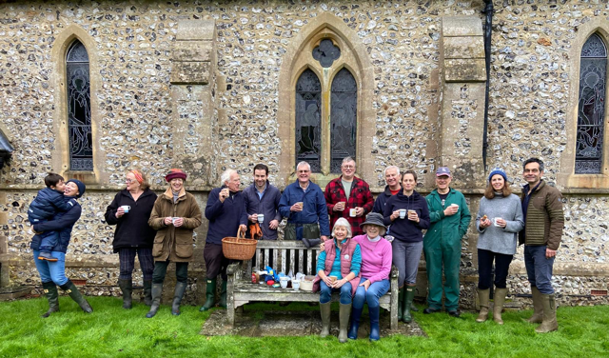

**St Mary’s School.**

The church school continued to flourish with 107 on roll and after a rigorous SIAMS inspection (Statutory Inspection of Anglican and Methodist Schools) in January of the school’s Religious Education, Collective Worship and spiritual values, received a glowing report from the Inspector

‘*The school’s Christian vision, expressed through values, and underpinned by biblical understanding, is deeply rooted in all decision-making. It forms the foundation of relationships, enabling pupils and adults to flourish within, and beyond, the school community.’*

Revd Jon Rooke continued to support staff and pupils with his weekly visits and presided over the many church services which the children organised to celebrate significant dates in the church year.

**Electoral Roll Officer**: Kirsty Ennever

Number on roll for 2024: Bentworth 70; Lasham 31; Shalden 44 Number on roll for 2025 and eligible to vote at the APCM: Parish of BLS 123

**Safeguarding Report:**

There have been no safeguarding incidents during the period of this report.

The Parish safeguarding officer is in touch with the Diocesan safeguarding team to keep up to date with the latest training and requirements. All PCC members and other eligible officers (such as bellringing tower captains) are regularly reminded of the need to make sure that their safeguarding training (basic and enhanced levels) are updated every three years, and that they have a DBS dated within the last three years. Several DBS checks for PCC members have recently been completed using the provider recommended by the Diocese.

**Financial Report:**

|  |  |  |  |
| --- | --- | --- | --- |
| **Parish of Bentworth, Lasham and Shalden Annual Accounts** | | | |
|  |  | **Year ending 31/12/2024** |  |
|  |  |  |  |
| **BLS GENERAL FUNDS 2024** | | |  |
| **Receipts** |  |  |  |
|  | Standing Orders |  | 16,104.00 |
|  | Gift Aid recovered on Standing Orders and GASDS | | 6,895.11 |
|  | Standing Orders (Glos) (excl Tax) | | 8,801.52 |
|  | Envelopes |  | 1,077.00 |
|  | Donations |  | 2,088.83 |
|  | Cash collections |  | 7,112.34 |
|  | Legacies |  | 0.00 |
|  | Charity Collections |  | 0.00 |
|  | Bank Interest |  | 1,382.75 |
|  | Village Fete |  | 1,100.00 |
|  | Parish Council |  | 1,200.00 |
|  | Parochial Fees |  | 1,872.00 |
|  | VAT Recovered (General Account) | | 0.00 |
|  | Other Income (Events) | | 562.33 |
|  | **Total Receipts** |  | **48,195.88** |
| **Payments** | |  |  |
|  | Parish Share |  | 28,432.00 |
|  | Utilities |  | 5,394.72 |
|  | Other expenses |  | 2,524.12 |
|  | Insurance |  | 6,621.12 |
|  | Clergy Expenses |  | 317.37 |
|  | Visiting Clergy |  | 0.00 |
|  | Cost of Services (incl organist, wafers etc) | | 814.46 |
|  | PCC Expenses |  | 457.13 |
|  | Bank Charges |  | 0.00 |
|  | Charitable Grants |  | 2,270.60 |
|  | General Maintenance | | 1,462.61 |
|  | Admin Costs |  | 1,000.00 |
|  | **Total Payments** |  | **49,294.13** |
|  |  |  |  |
| **BLS General Fund Balance for Year 2024** | | | **-1,098.25** |
|  |  |  |  |
|  | **FABRIC FUND BENTWORTH** | |  |
|  |  |  |  |
| **Receipts** |  |  | 2,797.70 |
| **Payments** | |  | 2,366.50 |
|  | **Total change during 2024** | | **431.20** |
|  |  |  |  |
| **TOTAL FF Account = £22,867.20** | | |  |
|  | | |  |
|  | **FABRIC FUND LASHAM** | |  |
|  |  |  |  |
| **Receipts** |  |  | 7,001.00 |
| **Payments** | |  | 2,280.00 |
|  | **Total change during 2024** | | **4,721.00** |
|  |  |  |  |
| **TOTAL FF Account = £** | |  |  |
|  | |  |  |
|  | **ORGAN and FABRIC FUND SHALDEN** | |  |
|  |  |  |  |
| **Receipts** |  |  | 6,089.45 |
| **Payments** | |  | 1,994.40 |
|  | **Total Change during 2024** | | **4,095.05** |
|  |  |  |  |
| **TOTAL O&F Account = £60,534.40** | | |  |
|  |  |  |  |



