
Parish of the Resurrection Alton
CONFLICT OF INTEREST POLICY
The purpose of this policy is to Protect the integrity of the POTR's decision-making process, to enable our stakeholders to have confidence in our integrity, and to protect the integrity and reputation of PCC and committee members.
PCC members have a legal duty to act in POTR's best interests when making decisions as a trustee. If there is a decision to be made where a trustee has a personal or other interest, this is a conflict of interest and you will not be able to comply with your duty unless you follow certain steps.
All PCC and committee members must therefore strive to avoid any conflict of interest between the interests of the POTR on the one hand, and personal, professional, and business interests on the other. This includes avoiding actual conflicts of interest as well as the perception of conflicts of interest. You must declare a conflict of interest immediately you are aware of any possibility that your personal or wider interests could influence your decision-making.
For example, as a trustee, you would have a conflict of interest if the POTR is thinking of making a decision that would mean:
- • you could benefit financially or otherwise, either directly or indirectly, through someone or some organisation you are connected to
- • your duty to the POTR competes with a duty or loyalty you have to another organisation or person

Conflicts of interest are common in charities — having a conflict of interest does not mean you have done something wrong. But you need to act to prevent them from interfering with your ability to make a decision only in the best interests of the charity.
Upon appointment each PCC and committee member must make a full, written disclosure of interests, such as relationships and posts held that could potentially result in a conflict of interest. This written disclosure will be kept on file by the Parish Administratyor and updated as appropriate.
In the course of meetings or activities, PCC and committee members must disclose any interests in a transaction or decision where there may be a conflict between the POTR's best interests and the member's best interests, or a conflict between the best interests of two organisations that the committee member is involved with.
After disclosure, in the interests of frank and open discussion, the PCC or committee member may be asked to leave the room and may not be able to take part in the decision, depending on the judgement of the other members present at the time.
Any such disclosure and the subsequent actions taken will be noted in the minutes which will record:
- • what sort of conflict of interest it was
- • which member or members were affected
- • if any conflicts of interest were declared in advance
- • an outline of the discussion
- • if anyone withdrew from the discussion
- • how any decision was made in the POTR's best interests

This policy is meant to supplement good judgement and PCC and committee members should respect its spirit as well as its wording. Oversight of this policy and any guidance that may be necessary in the interpretation of it rests with the Administration and Finance Committee.
Signed:
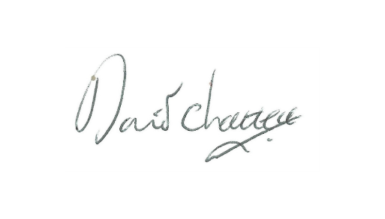

Published: September 2025
Review due, by the PCC –September 2028

